Adapting a Recipe to Suit the Islamic Culture
You name
Id #
Course No. : SSC0081
International Studies
Submitted to: Instructor name
Due Date:
Algonquin College- Kuwait

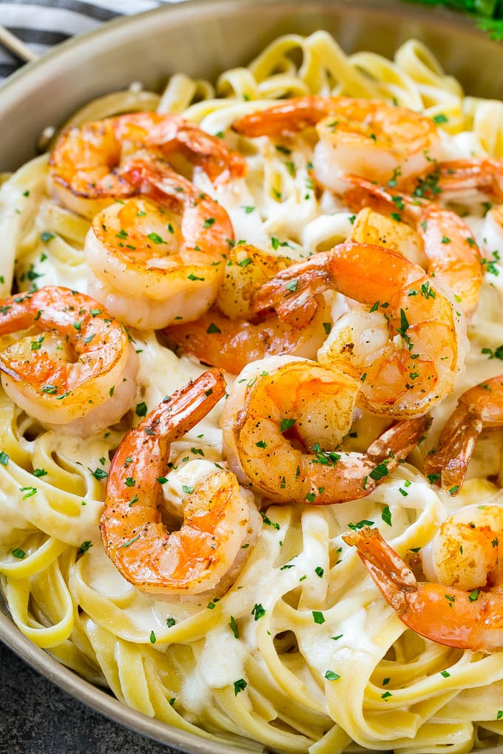
Student Name:
Student No.:
Course No. : SSC0081
International Studies
Due Date:
Fettuccine Alfredo Pasta Dish

International Product Report:

Table of Contents

Introduction 2
The Discussion 2
Conclusion 2
References 3

Introduction
Fettuccine Alfredo or fettuccine al burro is an Italian pasta dish made of fresh fettuccine mixed with Parmesan cheese and butter. As the cheese melts, it creams the liquids to form a smooth and rich sauce covering the pasta (Carnacina, 1975, p. 72–73). The dish is named after Alfredo di Lelio, who introduced it at his restaurant in Rome in the early- to mid-20th century (Downie, 2011, p. 106).

The Discussion
The recipe of Fettuccine Alfredo was accredited to an Italian chief called Alfredo di Lelio. It was including only three ingredients: fettuccine, young Parmesan cheese and butter (Popik, 2009). The "secret" of the original Alfredo recipe may in fact be simply that the fresh fettuccine, cheese and butter are tossed continuously with some pasta water in a well-warmed platter to ensure that they melt together thoroughly.
By 1922, Alfredo's fettuccine dish became widespread and ultimately spread to the United States, where it remains popular. The recipe has changed, and its commercialized version with heavy cream and other ingredients becomes international. In the United States, it is often served as a main course which may be combined with shrimp, or chicken and is known as “seafood alfredo", and "chicken alfredo" respectively. American restaurants also added cream sauce and garlic to Fettuccine Alfredo recipe. The cream sauce was made of white wine to give the pasta dish a special flavor and to make it taste too much like alcohol. The fettuccine alfredo with chicken or shrimp becomes very popular main courses all over the world as Italian-style cuisine with special touches from other cultures (Boldt, (n.d.)).
In Muslim countries, the recipe of Fettuccine Alfredo dish has been adapted to convey the rules of Islamic religion. Since the wine is prohibited in this religion, white wine or any Alcohol derivatives has been dispensed from the creamy sauce of all Alfredo pasta dishes. Thus, the creamy sauce is simply formed from milk thickened with starch.

Conclusion
In my opinion, adapting a product to meet the needs of the local markets, the culture of the country, or even a specific sector of customers is considerable undertaking and an important factor for successful product marketing. Pasta dishes with creamy sauce containing white wine will not be accepted in the countries of the Islamic world. In addition, I am not against using food recipes inspired by different cultures or international cuisines, taking into consideration the local requirements, especially the country's religious.

References

David, Downie. (1 February 2011). Cooking the Roman Way. p. 106. ISBN 9780062031099.
Barry, Popik. (14 February 2009). Fettuccine Alfredo. Retrieved from https://www.barrypopik.com/index.php/new_york_city/entry/fettuccine_alfredo
Carnacina, Luigi; Buonassisi, Vincenzo (1975). Roma in Cucina (in Italian). Milano: Giunti Martello.
Andrea, Boldt. (n.d.). Tips to Cook Pasta with White Wine. Retrieved from https://www.livestrong.com/article/553692-tips-to-cook-pasta-with-white-wine/

